EX-1:

CREATE VIEW view_dept50

AS SELECT employee_id,first_name, last_name,salary

FROM copy_employees WHERE employee_id = 302;

SELECT * FROM view_dept50;

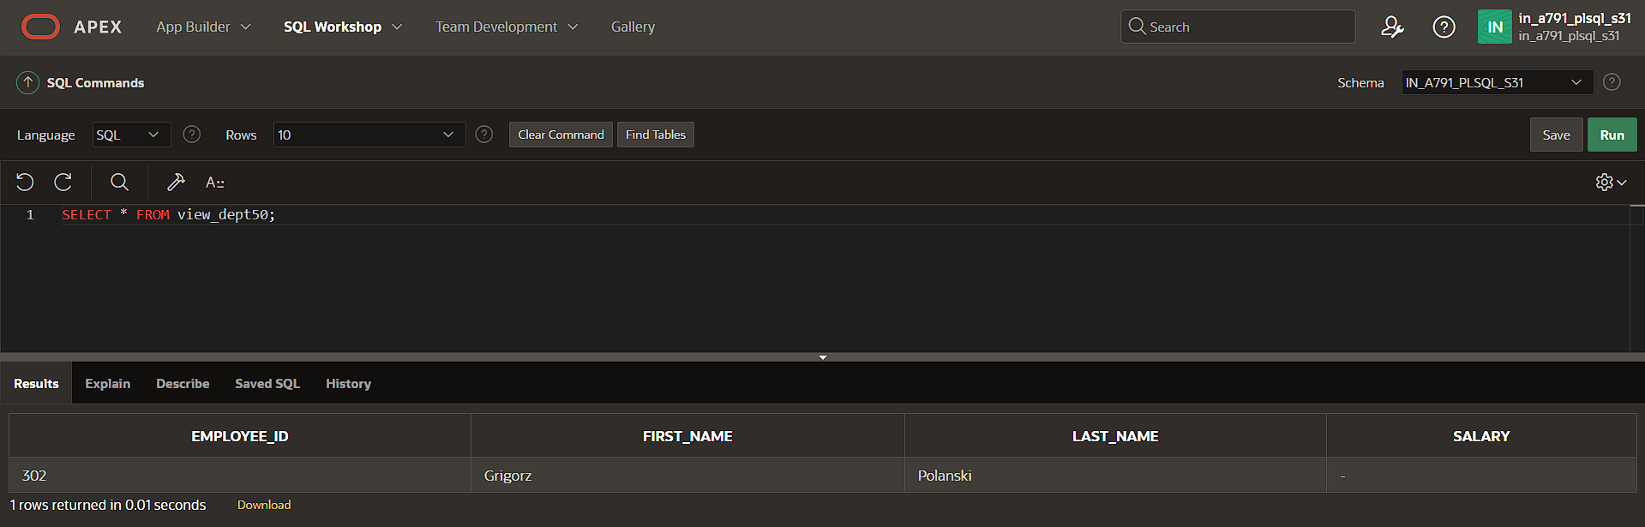

EX-2:

CREATE VIEW view_dept50

AS SELECT employee_id,first_name, last_name,salary

FROM copy_employees WHERE employee_id = 302;

UPDATE view_dept50 SET EMPLOYEE_id = 301 WHERE EMPLOYEE_id = 302;

EX-3:

CREATE OR REPLACE VIEW view_dept50

AS SELECT emp_id,salary FROM emp

WHERE emp_id = 302 WITH READ ONLY;